

SU President 2023-24 AGM Report
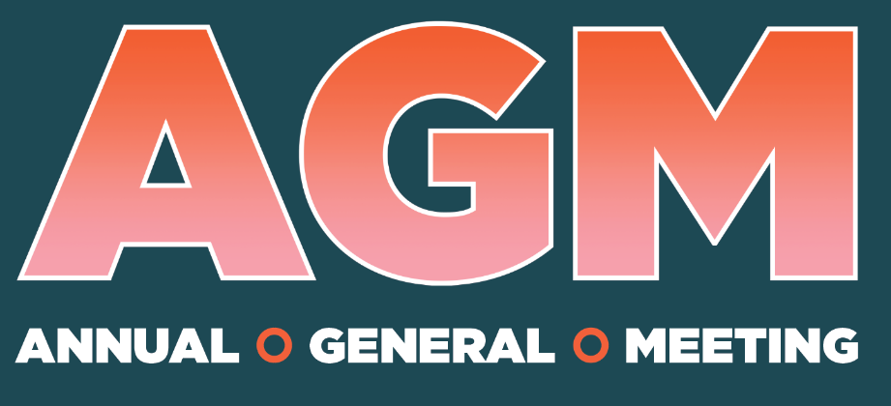
SU President 2023-24 AGM Report
Being fortunate to have been elected as the Union President of the Students’ Union for two terms has been an exciting and fulfilling journey. My role is to represent the collective student voice to the University in highest-level meetings. I lead the sabbatical officer team and engage with the student body to gather feedback and consensus.

The role comes with its challenges and rewards which really helped my personal and professional development.

My manifesto for this year
Improve the student voice of Warsash Maritime cadets
Represented main themes such as accommodation, communication and quality of teaching/learning.
- Lobbied the University to improve accommodation. Solent secured 75 rooms in Lucia Foster Welch this academic year for WMS (Warsash Maritime School) cadets.
- Lobbied the University to have more consistent Library opening hours to support WMS cadets.
- Closely working with the elected WMS Liaison Officer to relay cadets’ consensus from St. Mary’s campus.
- One of the favourite Students’ Union events has been Warsash Pub Meet-up – a great opportunity to improve the engagement with the cadets and understand their perspective on variety of topics such as campus culture, teaching/learning, and campus facilities. Over 200 cadets have attended the 3 meetups this academic year.
With my remaining time in post, I will continue to work with the elected WMS Liaison Officer and represent the approved motion submitted to the Student Council meeting in November.

Lobby the University to provide more support for international students
Represented main themes from international students’ feedback and course committee meetings such as block timetabling to support commuting and/or part-time working students, tuition fee payments issues, and overall learning experience, as well as adjusting to the life in the UK.
- The three sabbatical officers (Union President, Vice-Presidents Education and Wellbeing) created a handbook specifically for international students to support their experience at Solent and in the UK. The handbook is available on our website, and we have printed out 500 physical copies – we have distributed almost 50%!
- Celebrated International Students’ Day on the 17th of November along with the International Student Advice team. The celebration included variety of sessions such as opportunities at Solent, SU services available, culture shock discussion, and many more.
- Along with Vice-President Education, we supported the promotion of GRIT workshop to students and encourage them to register and participate. GRIT workshop is a two-day workshop opportunity to explore and celebrate identity, leadership and empowerment from black, Asian and other ethnically diverse communities within the university. 12 students have participated in the workshop and provided positive feedback of their experience.
I have thoroughly enjoyed engaging with international students through celebrating different cultures and representing different student perspectives. I will continue to represent the need for another multi-faith room along with Vice-President Education, and elected Religion and Faith officer. As well as representing the

Improve and support the library services
The library has been one of my focus of improvement and supporting as it is heavily accessed by the students. Represented main themes such as consistent opening hours, allocation of more loanable laptops, as well as designated space for different student cohort.
- Vice-President Education and I represented student voice in the Library remodelling project happening over the next five years. We represented student perspective from international students, WMS cadets, and parents/carers.
- Vice-President Education and I represented and supported the consistent opening hours of the library to accommodate students.
- Supported with computer system upgrade in the library through providing student feedback. The library has now 24 new M3 iMacs equipped with Final Cut Pro (video editing software), 20 brand-new high-spec Alienware PCs.
The library is currently performing a satisfaction survey to understand which facilities are going well and to improve. I have been supporting the library with the survey and will continue working close with library management in terms of representation.

Enhance the postgraduates’ student experience
Represented main themes such as awareness of SU services, directed learning requiring more contact between students and lecturers, block timetabling tuition fee payments issues, and overall learning experience.
- The sabbatical officer team have been present in course committee meetings and provided introduction to SU services available.
- Represented blocking timetable for postgraduate students to support different students’ needs – accommodate part-time jobs, ease the commuting, and parents/carers.
- Lobbied the University to have consistent opening hours to support students.
I will continue to engage with postgraduate students and represent feedback.

My campaigns for this year
Let’s Talk About Sex (Sexual Health Awareness)
The aim of this campaign is to spread awareness of various STIs and tackle the stigma around seeking sexual health support. I am significantly proud and very pleased how this campaign resulted and the progress I have made over the last two years of my term.
- Solent Students’ Union is now officially a Get-It-On centre which is a condom distribution scheme from NHS Solent Trust. Solent students have now access to free condoms and pregnancy tests in campus.
- Free condoms and pregnancy tests are now available in campus – to support students through the cost-of-living crisis. Student don’t need to worry about spending money on condoms or pregnancy tests. I have extended the free condoms to St. Mary’s campus for WMS cadets to access.
I will continue to make this campaign a staple service of the SU.

#ManDownSolent (Men’s Mental Health)
This aim of this campaign is to tackle the stigma of reaching out and seeking mental health support. I am very proud of the progress of this campaign over the last two years.
- Held a pre-launch (pop-up) event to ask students how they de-stress to get an idea what kind foe elements they want represented in this campaign.
- Music event – one-way students de-stress is through listening/playing music. The SU organised a music event called, SU Presents which allowed students to showcase their talents and express their emotions through the power of music. Four student artists performed including myself. The event was supported by our very own Live Event Society (LES) with the production side. The event was attended by 23 students and received positive feedback from the audience and performers.
- Gaming Event – another way students de-stress is through playing games. The SU organised a gaming event in the Spark – FIFA on the big screen in the Spark, along with retro arcade games, driving simulator. It was attended by 160 students and gave away 6 Xbox 360 as prizes to beat the sabbatical officer team in a game of student’s choice.
With my remaining time on post, I will conclude this campaign with the Lions Barber Collective coming into campus to give free haircut to students and talk about mental health. The Lions Barber aims to raise awareness for mental wellbeing and suicide prevention. Encouraging barbers to create a safe place for men to open up and offload and being able to signpost to already existing charities and organisations.

Safe Southampton
This is an ongoing joint campaign with Vice-President Wellbeing with the aim to represent student voice to Hampshire Constabulary the safety of Solent students.
- We are currently in progress of creating a survey to ask Solent students where in the City they feel unsafe.
- We will launch the survey soon and present it to Hampshire Constabulary.

Other key/notable activities
- NUS Affiliation Referendum – in September 2023, we held a referendum for the SU’s affiliation with the National Union of Students. The referendum received 416 voters, of which 365 could be counted. This surpassed our quota of 300 to a referendum to be considered valid. A total of 324 students voted to state Solent Students’ Union should disaffiliate from National Union of Students. Some 33 students voted to remain affiliated, and 8 abstained from voting.

Solent students have voted for Solent SU to disaffiliate from the NUS. We have notified the NUS about our affiliation which will end of the 31st of December 2024.
- Facial Recognition Scheme – GO! Southampton is the Business Improvement District for the City. They are trialling a new facial recognition technology to tackle crime in the City centre. I attended the pre-launch event to understand how it would affect Solent students’ experience in the night-time economy. I was also interviewed by Daily Echo regarding the event and presented the student feedback.
- Teaching Excellence Framework (TEF) – Solent University has achieved triple-gold TEF award by the Office for Students for their submission. I had written Solent’s counterpart student submission back in March 2023.

Conclusions
It has been an active year for the SU and the sabbatical officer team with all the changes and improvements. With three months remaining in my post, I will continue representing student voice to Solent as well as the Council to improve student experience.
I am currently working with Solent on their submissions for Access and Participation Plan, and University Mental Health Charter. The submission dates will be after my term therefore I will draft the student submissions before the end of my term.
The sabbatical officer team are currently working with the University in allocation of student-owned space. We are in feedback gathering stages and will have to create a proposal to the University.
I hope to see you all in graduation in July.
I can’t thank enough my SU team and the Board of Trustees for all the support and guidance. A massive thank you to all Solent University staff members (Vice-Chancellor’s Group, Board of Governors, Estates & Facilities team, and especially the Sodexo team) for their continuous support. I truly couldn’t have achieved many things without their support and guidance.
Lastly, I want to thank the Solent students. Thank you for electing me twice – this role has been life changing. I was able to meet many different students from different walks of life, learned about many different cultures, and most importantly I got to wear fancy suits. It has been an absolute pleasure representing you all and more. It is truly an honour to be in this position.
WINST OUT

